Ric Generator (Framework) HLD

# Overview

Ric Generator is a window form tool used for grabbing and parsing information from the download data from web site. It’s an execution file. Major features by now:

* Tree-model task organization;
* Task scheduling;
* Task configuration;
* Task result viewer;
* Task status tracking
* Database support

**Ref Documents**:

Spec: [Ric Generator Spec.docx](Ric%20Generator%20Spec.docx)

User Guide: [RicGenerator User Guide.docx](RicGenerator%20User%20Guide.docx)

# Architecture

This tool is implemented by three layers: UI layer, business logic layer and database layer. (Figure1: High Level Design). There’s unified interface between each layer. Following is the detailed introduction of each layer.



*Figure 1: High Level Design*

## 2.1 UI Layer

There’re task manager form, configuration form, task result form and timer form. Corresponding to each form, there’s a controller/ manager to implement the UI logic.

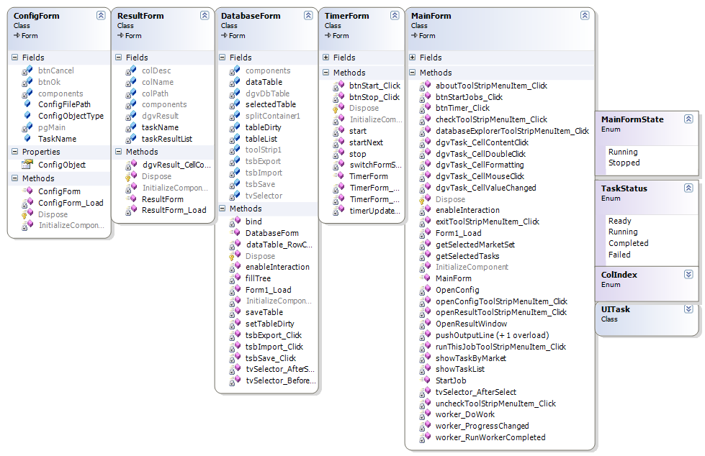

Figure 2: UI Class Diagram

## 2.2 Business Logic Layer:

Implement the requirements reported by users. Currently, tasks of the same market are build together into an assembly. By now, there’re “RicGeneratorLibHK”, “RicGeneratorLibKorea” and “RicGeneratorLibThailand”.



*Figure 3: Business Logic Layer Process Flow*

For execution part:

All tasks inherit the same “GeneratorBase” and override “Initialize ()”, “CleanUp ()” and “Start ()” method.

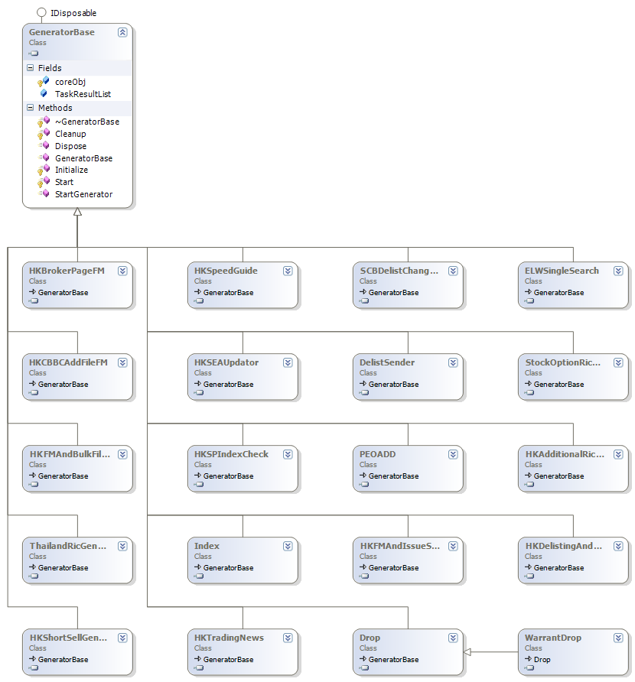

For each task,



## 2.3 Datebase Layer:

Adopt mySQL as the database. The reference map information is stored in database. For this layer’s implementation, there’re table entities and table managers. Table information is defined in table entity and corresponding to each table, there’s a table manager to implement the operations like delete, add, update and so on.

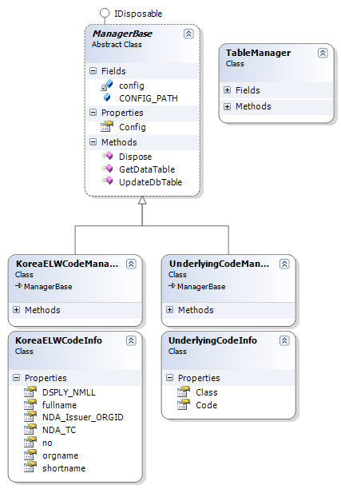

Figure

## 2.4 Shared Module:

Besides the above three layers, there’s a separate module “Ric.Shared”. Shared logic and components are implemented in this module. The common methods are encapsulated.

